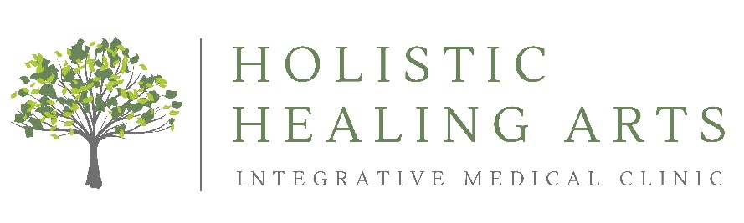
TRAVELING CHECKLIST
Holistic Healing Arts understands traveling for treatment requires a lot of preparation, thought and energy. The following information provides helpful tips to help you on your journey in coming to our office and making the most of your time here.
1) CHECK AVAILABLE APPOINTMENTS
- Call or ChARM message our ‘Scheduling’ department with your providers traveling appointment instructions per your ‘Encounter’ / protocol. Please be specific in the number of days you plan to be in-office, what provider(s) you wish to schedule and any additional services (IV, lymphatic treatment, sauna, ionic footbath, etc.) to be included. If you prefer to separate services per your body’s tolerance, please indicate the preferred layout.
- Allow the ‘Scheduling’ department to confirm your traveling appointments have been made. Please check your traveling schedule in your ChARM portal under ‘Appointments’ to ensure you are satisfied with the appointment layout and times.
2) FLIGHTS
- Purchase flights at one of the following airports:
1) Paine Field Airport is in Everett, WA and 7 miles from Holistic Healing Arts.
2) SeaTac – Tacoma International Airport is in SeaTac, WA and 30 miles from Holistic Healing Arts.
- Include travel insurance when purchasing your flights for a variety of reasons. Weather can be unpredictable in the pacific northwest, especially during the fall and winter.

3) ACCOMODATIONS
- We have complied an lodging list for traveling patients. Holistic Healing Arts discounts / rates are listed. If you have a positive experience and/or find accommodations for chemically sensitive patients, we would love your feedback!
4) PACKING
- Please bring in your supplements and medication to your doctor appointment. To reduce luggage bulk, place one dose (pill/capsule) in a small baggy and label it accordingly (i.e., brand, full name, dosage). For liquids, place some on a cotton ball prior to bagging.
- When packing items that need to remain cold, place the supplement/medication in a double walled thermos with an ice pack. Please keep this in mind when booking your accommodations as some hotels do not have cold storage available.
- Wrap homeopathic remedies / supplements in aluminum foil. This will help protect the homeopathic energetics when going through TSA x-ray machines.

5) MEAL PLANNING
- If you are staying at an accommodation without a kitchen, the following organic options are located nearby:
- The Secret Ingredient – Custom meals for individuals & families with dietary restrictions.
Please visit www.secretingredientmeals.com for more information.
- Whole Foods Market - 1 mile away from Holistic Healing Arts.
- PCC Community Market Co-op – 5.5 mile away from Holistic Healing Arts.

6) TRANSPORTATION
- Mass transit is limited in the Lynnwood area. Many of our patients either:
1) Rent a car
2) Find an accommodation that provides a shuttle service to and from.
3) Rely on a car service (e.g., Uber, Lyft).
Please note, if you have several family members scheduled for appointments, we recommend renting a car and/or staying at a nearby accommodation to limit the amount of people in our waiting room.

7) FINANCES
- We recommend placing a ‘Travel Notification’ with your financial institution, especially if you are an international patient. You may need to give permission for Holistic Healing Arts to charge a large sum (during check out).
7) ARRIVING FOR YOUR APPOINTMENT
- Holistic Healing Arts provides a fragrance-free environment to our chemically sensitive patients and staff. Please do not use any products, perfumes when coming to our office.
- Please come to your HHA appointment(s) well hydrated.
- We recommend bringing additional water and snacks/lunch for longer appointment days.
- If you are scheduled for an IV, we recommend bringing warm layers.
If you have any questions, please call or ChARM message our ‘Scheduling Billing’ department. We are happy to help!

